ÇANKAYA UNIVERSITY
FACULTY OF ENGINEERING
COMPUTER ENGINEERING DEPARTMENT

CENG X00 (write “200” or “300”)

SUMMER INTERNSHIP
REPORT

Name Last Name
Student ID

Company:
Name of the Company

Internship Period:
**/**/**** – **/**/****

STATEMENT OF NONPLAGIARISM

I hereby declare that all statements in this statement have been obtained and presented in accordance with academic rules and ethical conduct. I also declare that, as required by these rules and conduct, I have fully cited and referenced all material and results that are not original to this work.

Name Last Name:
Date:
Signature:

ABSTRACT

You should provide a short (no more than 200 words) abstract in your report. This abstract should describe your internship in a few sentences, mainly stating where, what you have done, and what you learned – just a general description.

TABLE OF CONTENTS

STATEMENT OF NONPLAGIARISM i
ABSTRACT ii
TABLE OF CONTENTS iii
LIST OF TABLES iv
LIST OF FIGURES v
1. INTRODUCTION 1
2. COMPANY INFORMATION 1
3. WORK DONE 2
3.1 X Project 2
3.1.1 Describing Code Work 2
3.1.2 Observations 2
3.2 Using References 3
3.3 Using Tables and Figures 3
3.4 Grading Criteria 4
4. CONCLUSION 6
REFERENCES 7
APPENDIX 8

LIST OF TABLES

Table 1. Technologies Used in the Report and Their Purposes 3

LIST OF FIGURES

Figure 1. Use Case of Multi Client-Server UDP Communication 4

1. INTRODUCTION
To use the template, create an empty version of this document and edit the text according to your internship. You should be using the format and writing styles defined in this template.
This section should include:
- The name of the company and department where you have done your summer internship, the main work fields of the company, and your motivation for choosing this company as the place for your summer internship.
- Summary of the work you have done, the motivation behind it, and the significance of the work that you have done in the overall project.
- Explanation of the organization of the report.

2. COMPANY INFORMATION
This section provides detailed information about the company and department where you performed your internship, its hardware/software systems and resources, its focus and project area, its organization, etc. The name, address, telephone number, email address, and information about the education of your supervisor must be given (including the name of the university and department from which he/she graduated, and the year of graduation). Additionally, you must list the names of your team members and their backgrounds. If you have worked with other interns from, for example Industrial Engineering, please write this information, as this can be considered as evidence for multi-disciplinary work.

3. WORK DONE
The number of sections in this part, their titles, and contents depend on the work that you have done and the information you would like to provide. However, this part should be at least 2000 words. It should explain the work you have done in your internship and should be consistent with your journals.

3.1 X Project
You can use subsections to describe different tasks you were assigned to. You are expected to discuss in detail the work you have done. For example,
- The algorithms/pseudo-code developed.
- Hardware/software environment used.
- Software tools used.
- Design methods used and learned.
- Testing methods and tools used and learned.
- Project management methods and processes followed or observed.
- Any engineering standards that are followed or observed.
- Design, development, documentation, and testing were participated in or observed.
- Any training received, including seminars attended.
- Any configuration and/or maintenance tasks performed.

3.1.1 Describing Code Work
Details about a system you have developed should be provided in your internship report. Do not just give a figure showing the full source code of the program you have developed. If you want to include source code, you can use the Appendix section.
In your report you can use Unified Modeling Language (UML) diagrams or simple pseudo-code outlining the work you have done. If the company forbids you to include sensitive information, you should try to add some information that will give us (the evaluators) some sense of what you have done.

3.1.2 Observations
You can add to your report your observations. Software engineering and the methodologies used in the companies are very important. Try to understand how the work is done and who decides what to do. How do they discuss it? How do they design it? How is the quality ensured? Try to figure out the roles and duties. When you are writing about tools or technology, do not focus on what they are; try to justify their use. It is important for you to notice the management and engineering skills required in your future careers.

3.2 Using References
When you are describing the work please keep in mind that you are not expected to teach a certain technology. The expected content is the thing YOU have done or noticed/observed during your internship. Please DO NOT borrow (plagiarize) any content from books, Wikipedia, or other websites directly and copy-paste it as if it is your own ideas. Not only will your internship be rejected, but also you will commit a punishable offense [1].
While directly copying from such resources is strictly disallowed you can refer to them and use material with proper CITATION. References should be provided in the IEEE citation format. Quotations in the text should be numbered like [1], [2]. You must provide at least a few references in your report. You can use books or articles as references [2]. While you can use websites and Wikipedia articles as well, please try to make sure that the information contained in them is accurate. Your references section should only contain sources you have used in your text and nothing else.

3.3 Using Tables and Figures
Tables and figures are a good way to explain a topic when used in correct places. For example, if you have programmed an application with a user interface, you can add some screenshots to describe the application. You should refer to the figure in the text (e.g., Figure 1 shows that). Always put a caption to your figure by right-clicking the image and selecting “Insert Caption.” You can use the “Cross-Reference” feature of MS Word to reference your figure from the text (you can find it in the references tab in MS Word).

Table 1. Technologies Used in the Report and Their Purposes
Technology | Version | Purpose
Python | 3.10 | Data processing
Docker | 24.0 | Containerization of applications
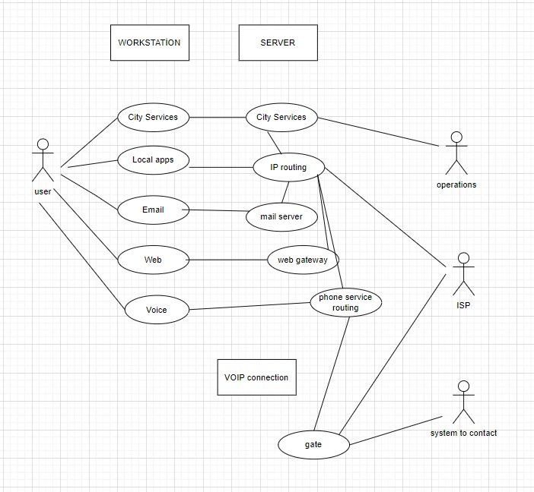
Figure 1. Use Case of Multi Client-Server UDP Communication

3.4 Grading Criteria
You should write your report according to the grading criteria. In your reports, we are expecting to see engineering qualifications. Consider the following 12 qualifications:
- Demonstrates the ability to apply mathematics, science and engineering subjects to model and solve engineering problems.
- Demonstrates the ability to identify, formulate and solve complex engineering problems.
- Demonstrates the ability to select and apply appropriate analysis and modeling methods.
- Have built a complex system, process, device, or product.
- Have used information technologies effectively.
- Demonstrated ability to select, devise or use modern techniques and tools.
- Have conducted experiments, gathered data and interpreted results investigating an engineering problem.
- Demonstrated good communication and presentation skills both orally and in writing.
- Have independently researched and learned by educating him/herself.
- Recognized professional and ethical responsibilities.
- Observed and participated in business life practices such as project management, risk management and change management.
- Demonstrated observations and knowledge about contemporary issues, global and societal effects of engineering practices.

You should write any evidence related to these criteria. Remember that you will get grades according to these criteria. You should note which pages you report relevant activities related to these qualifications so that you can write it to your “Intern Self-Evaluation Questionnaire.” You should include the “Intern Self-Evaluation Questionnaire” and “Grade Form” at the end of your internship report.

4. CONCLUSION
Write a conclusion section where you summarize the work you have done. Restate your contribution, what you have learned, experienced, and acquired. Be specific in relating these to what you have learned at Çankaya University.

REFERENCES

[1] Çankaya University, “Çankaya Üniversitesi Ön Lisans ve Lisans Eğitim ve Öğretim Yönetmeliği,” 2024.
[2] R. L. Massengale, “Implementing an effective internship program,” Journal of Computing Sciences in Colleges, vol. 27, no. 5, pp. 24-31, 2012.

APPENDIX

